

**SVKM’s NMIMS**

**Mukesh Patel School of Technology Management & Engineering, Shirpur**

**A REPORT ON**

**“Hotel Website”**

By

Shaswat Samaddar (N273/70471119077)

Dhrumil Talati (N288/70471119094)

MBA Tech (Computer Engineering) III Year

Academic Year 2021-22

# “Hotel Website”

# **ABSTRACT: -**

Over the years, the Internet has dramatically changed the way people use computers and communicate today. Many Internet terms have become part of people's everyday language, and e-mail has added a whole communication. By the turn of the century, information, including access to the Internet, will be the basis for personal, economic, and political advancement. The popular name for the Internet is the information superhighway. Whether you want to find the latest financial news, browse through library catalogs, exchange information with colleagues, or join in a lively political debate, the Internet is the tool that will take you beyond telephones, faxes, and isolated computers to a burgeoning. This project aims to build a website that will be suitable for booking a room at a hotel online and to check out the reviews and ratings of customers, pictures of the room the user is opting for, and the facilities and services included in the booking. The website design will consist of the frontend as well as the backend..

# **INTRODUCTION**

Every hotel’s goal is to sell more rooms and make a profit. Yet, you will have to rely on phone calls and walk-ins only to make reservations without an online booking system. An online booking platform is а necessity. That’s why we would like to point out the key benefits every sound hotel booking system should bring you. There are several  benefits of online hotel booking, some of them are listed below:

1. **They work 24/7:** One of the most significant benefits of an online reservation system is that they are always open for business. You can accept bookings 24/7, so your customers don't have to wait until the next day to make a reservation or worse, turn to one of your competitors.



1. **Hassle-free management of booking:** Clients have the convenience to book when it's right for them, and you collect bookings while you sleep. Plus, bookings can be made at their own convenience from the comfort of their home. Eliminate the need to call up the facility to ask for details or go to one and struggle to find a suitable slot to book. Your business can keep its calendars full throughout the year!
2. **Business analytics would be easier:** A booking software keeps track of each reservation and every detail that goes with it. You can use reports to find what kind of bookings are making you the most money, get a better understanding of who your typical customer is, and have accurate insights into your cash flow. An online booking software gives you the ability to make data-driven decisions and grow your business.



1. **Increase in revenue:** Clients have the convenience to book when it's right for them, and you collect bookings while you sleep. Plus, bookings can be made at their own convenience from the comfort of their home. This would lead to an increase in revenue.



1. **Reach of the hotel would increase:** There's a multitude of businesses out there who have a website and are listed on Google, but only a few have an online booking system in place. By having an online reservation system, you're one step ahead of the game, tipping the scales in your favor when prospects research and compare your capabilities against your competitors.



1. **Payments are more secure and faster:** With the security of the web, every transaction would be tracked and payments would be facilitated by the biggest secured payment portals. Every transaction would have a record so it would help the government to catch the firms and businesses trying to evade taxes. Refunds would be easier to process and the transactions would be hassle-free.

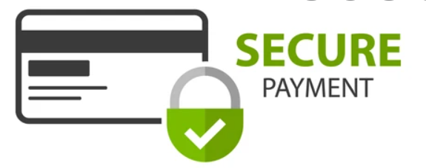

1. **Human intervention will be lee thereby decreasing the workload by automating bookings:** Taking bookings via the internet (website) would lead to a cost-cutting for the hotel since it would need to employ fewer people on the front desk for entertaining walk-ins and booking calls.



The website proposed in this project will help the customers easily sign up through their email address after verification and create a free account to access special discounts and save payment details for hassle-free and faster payments. This website would show the images of the rooms a customer is booking along with the prices and customer ratings and reviews for the same. Once a customer has signed up with the hotel’s website they can easily log in to book their stay after selecting the dates of check-in and check-out, number of rooms, and number of guests. The website is designed to make the hotel attractive for its customers and enhance the user experience, the frontend is developed with the help of HTML for basic structuring and CSS is used for providing attractive colors, transitions, and effects while booking a room. Records of the customers will be maintained in a database which would be maintained by PHP and MySQL. There will be primarily four pages included in the website.

1. Login page for existing users or Sign-up page for new users.
2. Hotel booking page sowing images of rooms, tariffs, reviews, ratings, dates of booking, number of guests, etc.
3. Payment page
4. Booking confirmation page.

## **PROBLEM STATEMENT AND SOLUTION**

What is the most common problem that we face, when we go on vacation?? The hotel reservations right? We need to roam around different places, check different rooms and the hotel’s services, and then finalize the hotel. This procedure is always very tedious and time-killing. Moreover to this, there are some other problems like:

1. Unclean Rooms

This is a common issue with lower-end hotels, but a complaint like this can happen even to the best hotels out there. Whether the room hasn't been adequately cleaned, or there are bed bugs or cockroaches walking around, uncleanliness is one of the biggest reputation killers when it comes to the hospitality industry.



1. No Hot Water

Imagine a guest arriving at a hotel, tired from a long trip, only wishing to take a long, hot shower. And to his surprise - there's no hot water!



1. Rude Staff

The hospitality industry is such that you just can't afford to have employees with an attitude

**Solution:**

Now, after these problems, what if I tell you that you can just avoid these awkward situations, sitting at your homes and just on a few clicks.

Here comes our Travelix website which can give you the best user experience.



You can check all the rooms before booking.  The photos of the rooms are available on our website. Booking the rooms can be very easy. You can book the rooms from our website through very less and easy steps.

All you need is an account for our website and done!!.

## **LIST OF TECHNOLOGIES USED**

1. HTML: It is used for the frond end development. Various semantic tags have been used. The **HyperText Markup Language**, or **HTML** is the standard markup language for documents designed to be displayed in a web browser. It can be assisted by technologies such as Cascading Style Sheets (CSS) and scripting languages such as JavaScript.

Web browsers receive HTML documents from a web server or from local storage and render the documents into multimedia web pages. HTML describes the structure of a web page semantically and originally included cues for the appearance of the document.

1. CSS: It is used for the beautification of the html frond end. **Cascading Style Sheets** (**CSS**) is a style sheet language used for describing the presentation of a document written in a markup language such as HTML.[[1]](https://en.wikipedia.org/wiki/CSS#cite_note-1) CSS is a cornerstone technology of the World Wide Web, alongside HTML and JavaScript.[[2]](https://en.wikipedia.org/wiki/CSS#cite_note-2)

CSS is designed to enable the separation of presentation and content, including layout, colors, and fonts.[[3]](https://en.wikipedia.org/wiki/CSS#cite_note-3) This separation can improve content accessibility, provide more flexibility and control in the specification of presentation characteristics, enable multiple web pages to share formatting by specifying the relevant CSS in a separate .css file which reduces complexity and repetition in the structural content as well as enabling the .css file to be cached to improve the page load speed between the pages that share the file and its formatting.

1. JavaScript: It has been used for the form validation at client side. **JavaScript** , often abbreviated as **JS**, is a programming language that conforms to the ECMAScript specification. JavaScript is high-level, often just-in-time compiled, and multi-paradigm. It has curly-bracket syntax, dynamic typing, prototype-based object-orientation, and first-class functions.

Alongside HTML and CSS, JavaScript is one of the core technologies of the World Wide Web.  Over 97% of websites use it client-side for web page behavior, often incorporating third-party libraries. Most web browsers have a dedicated JavaScript engine to execute the code on the user's device.

1. PHP: It has been used for the validation at the server side and various concepts of cookies and session have been used. PHP is a server scripting language, and a powerful tool for making dynamic and interactive Web pages.

PHP is a widely-used, free, and efficient alternative to competitors such as Microsoft's ASP.

1. MySQL: There are various table made in the sql. **MySQL**  is an open-source relational database management system(RDBMS). Its name is a combination of "My", the name of co-founder Michael Widenius daughter and "SQL", the abbreviation for Structured Query Language. A relational database organizes data into one or more data tables in which data types may be related to each other; these relations help structure the data. SQL is a language programmers use to create, modify and extract data from the relational database, as well as control user access to the database. In addition to relational databases and SQL, an RDBMS like MySQL works with an operating system to implement a relational database in a computer's storage system, manages users, allows for network access and facilitates testing database integrity and creation of backups.
2. Framework used:NA

## **PROJECT GALLERY**

Home Page:

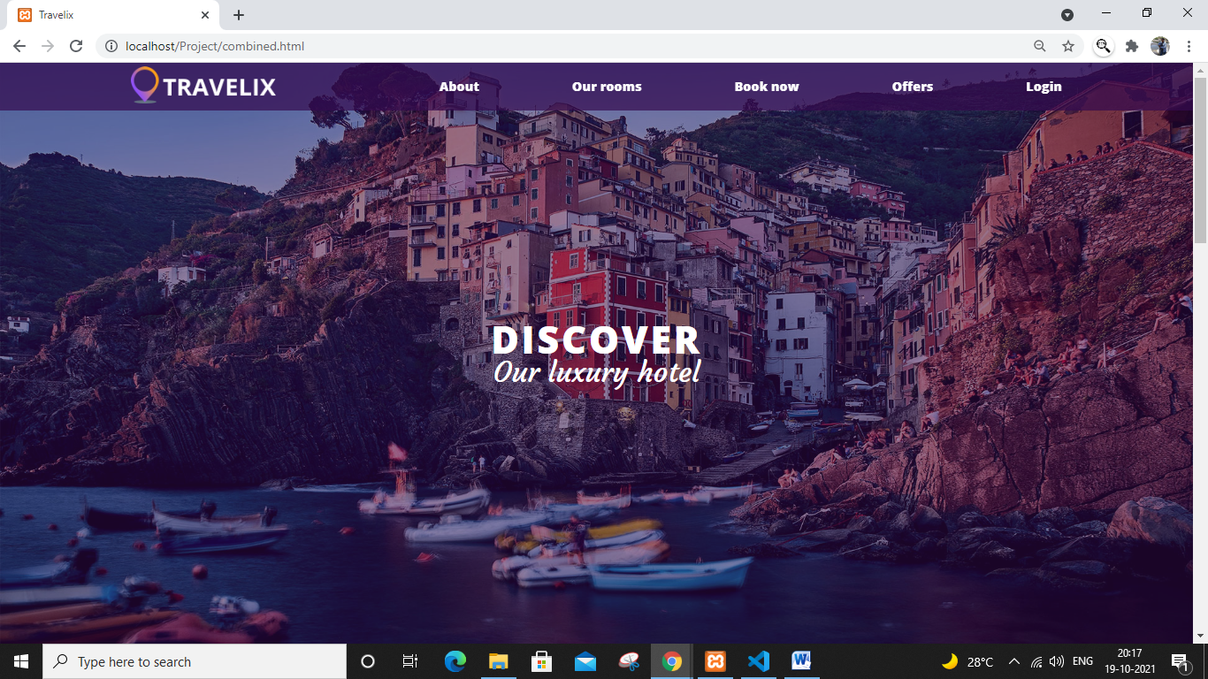

Fig 1: it has our basic features like about us, our rooms, booking, offers and login.

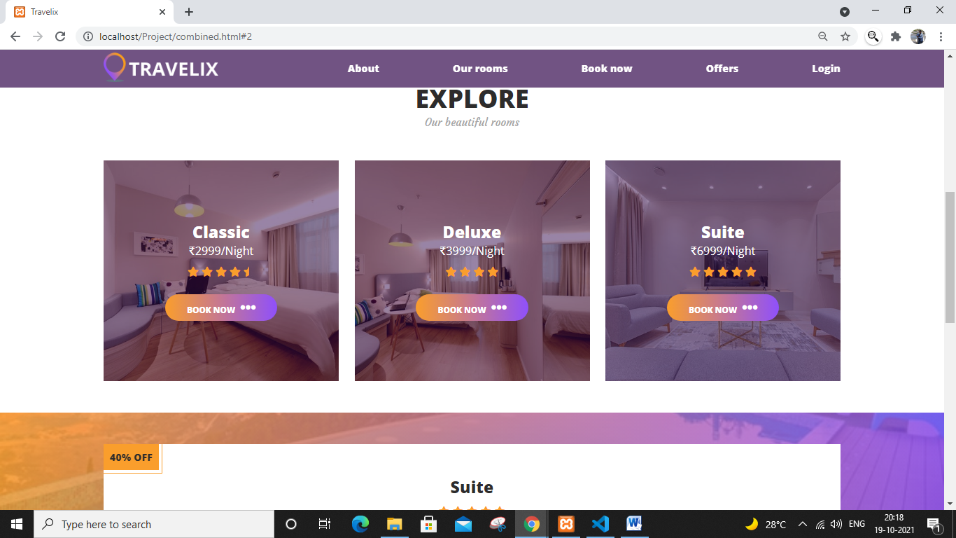

Fig 2: on clicking **Our rooms**  the page is scrolled to this explore part

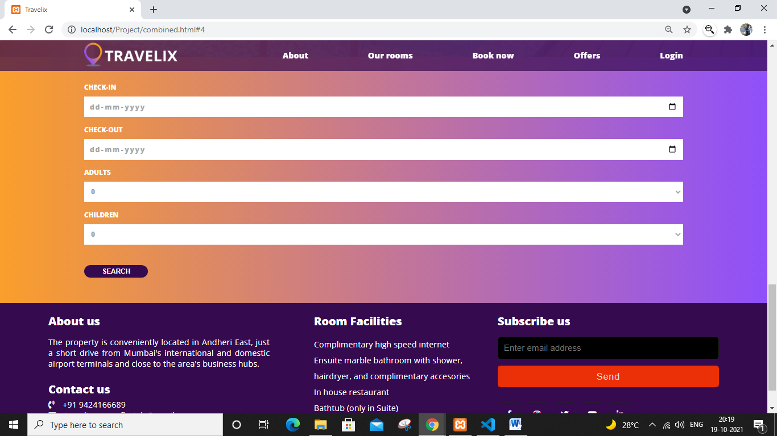

Fig 3: On clicking **Book now** it takes us to this part

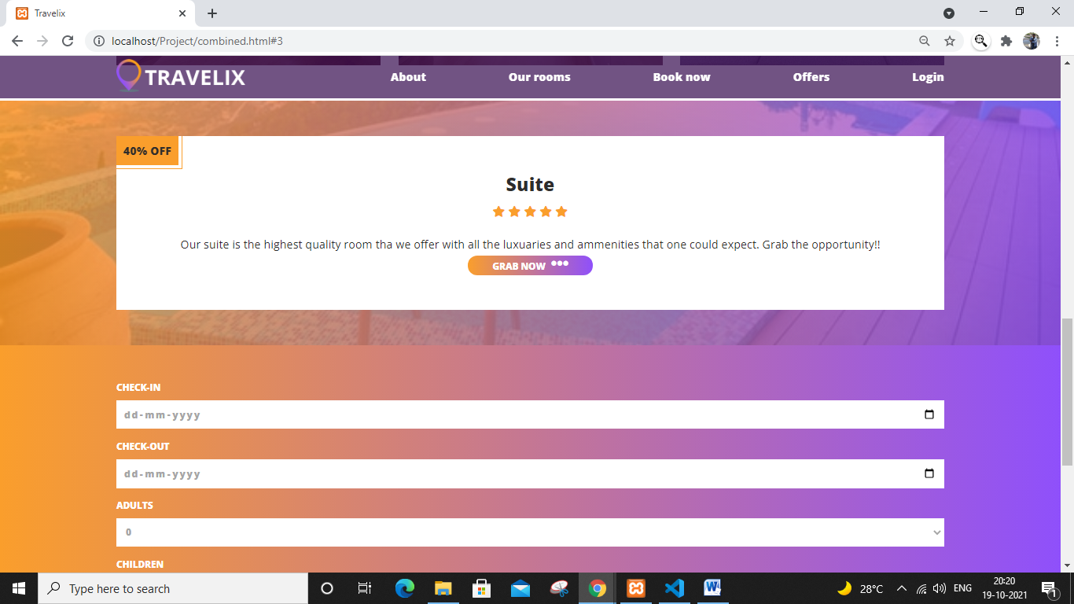

Fig 4: On clicking **Offers** , it brings to this part of the page

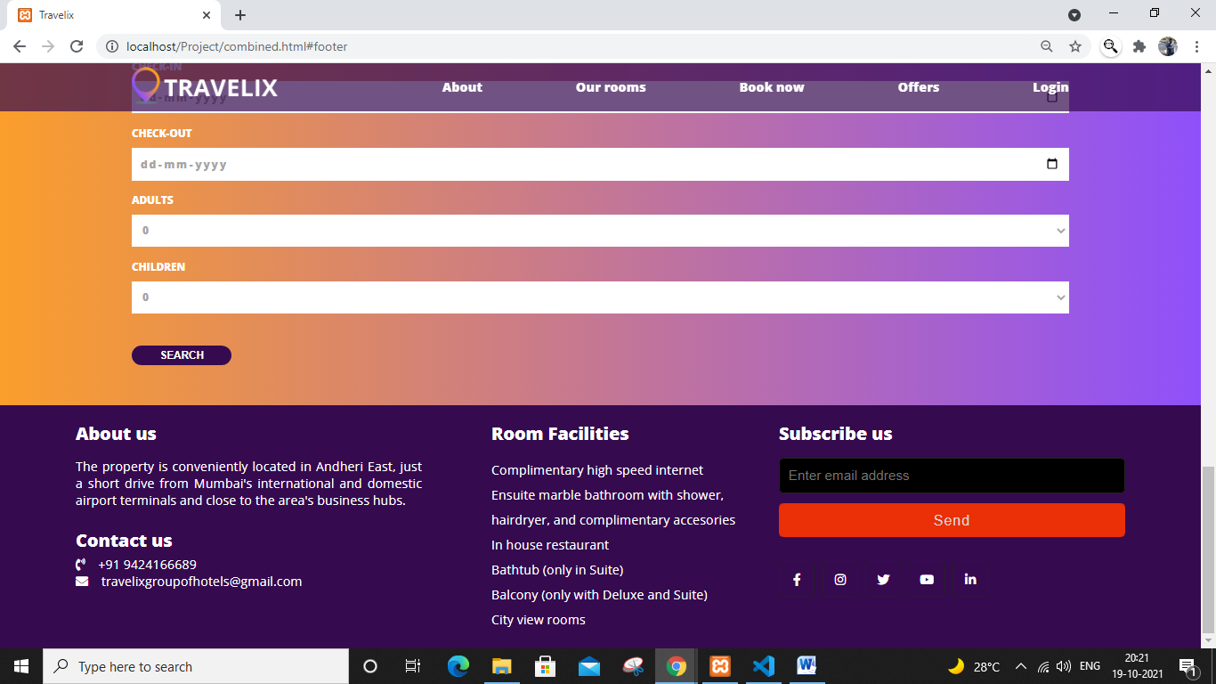

Fig 5: on clicking **About** , it takes us to this part of the page

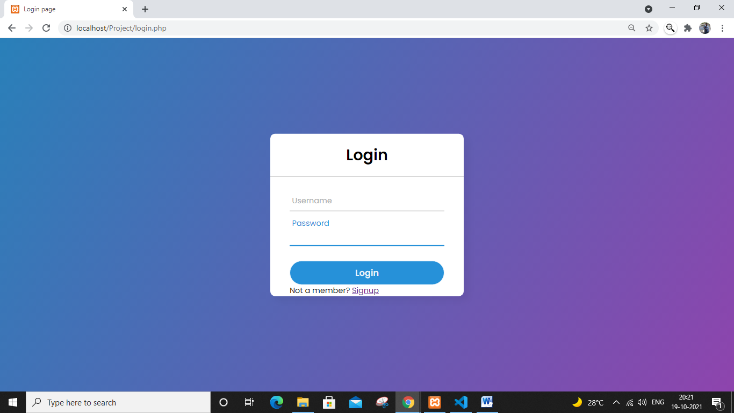

Fig 6: On clicking the login button it is redirected to a new page, which is the login page.

Now if you are not a member of our hotel, then it takes us to the following page:

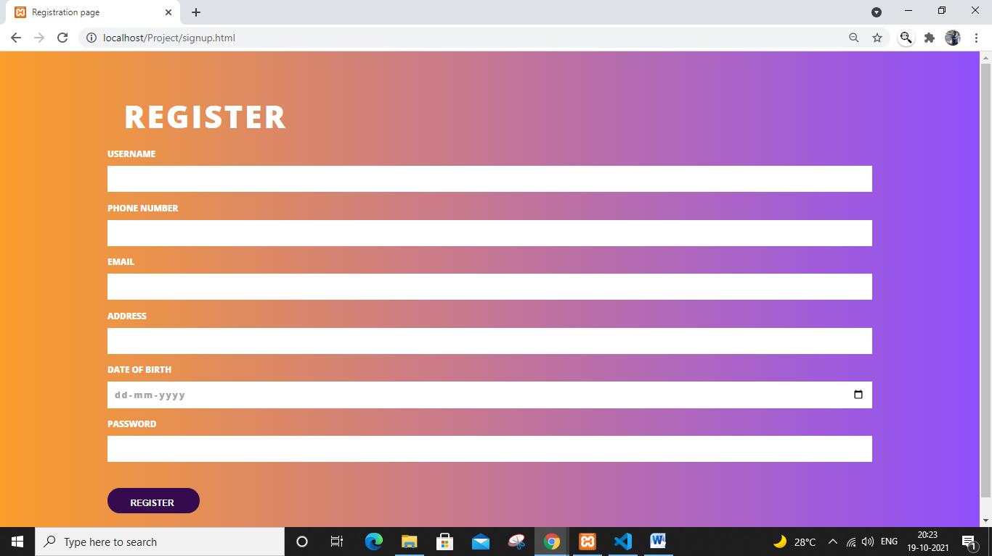

Fig 7: After registering, you’ll be again taken to the login page.

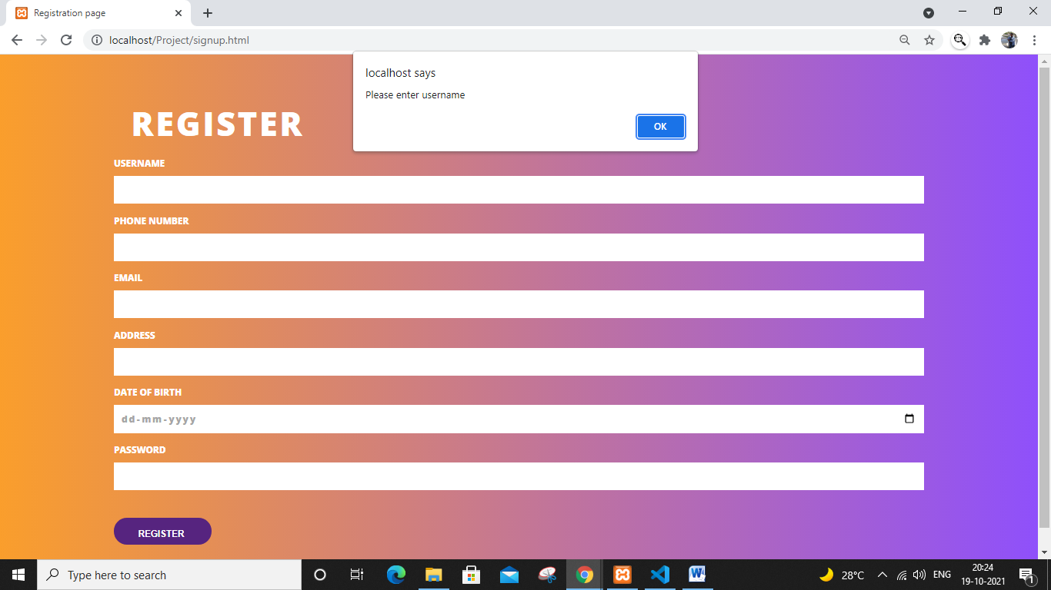

Fig 8: it shows us the various validation of the page. If we enter a email like “abcd” then it will give incorrect email, which can be seen below

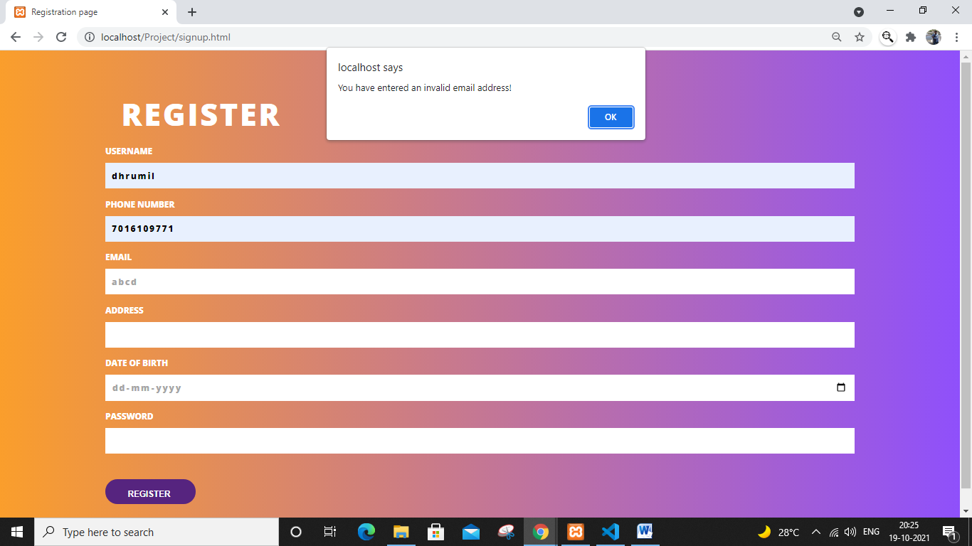

Now we’ll enter the details and click register

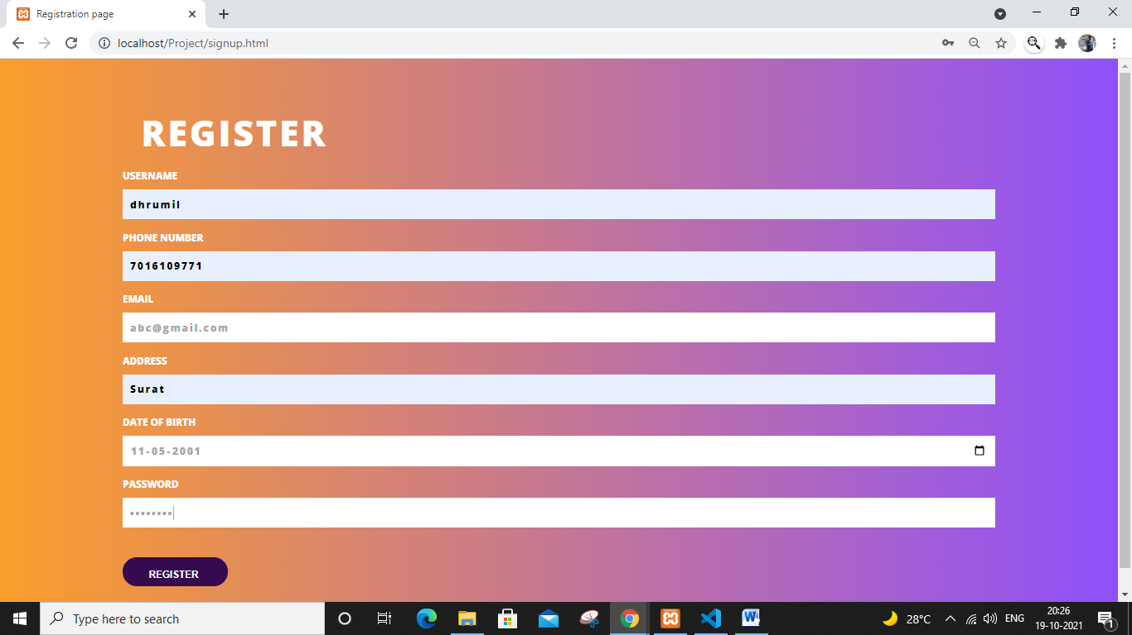

Fig 10: these are the details we enter. The password should also have a capital, number etc.

Now we’ll register

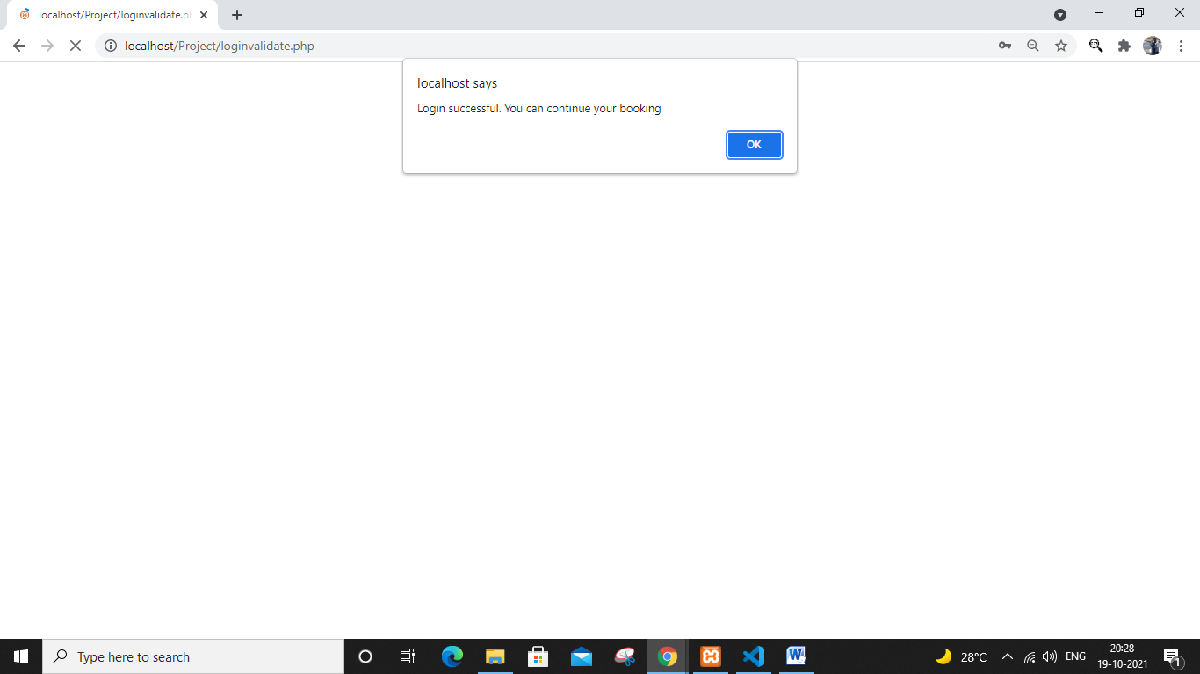

Fig 11:On successful login, it gives us this message and redirect here

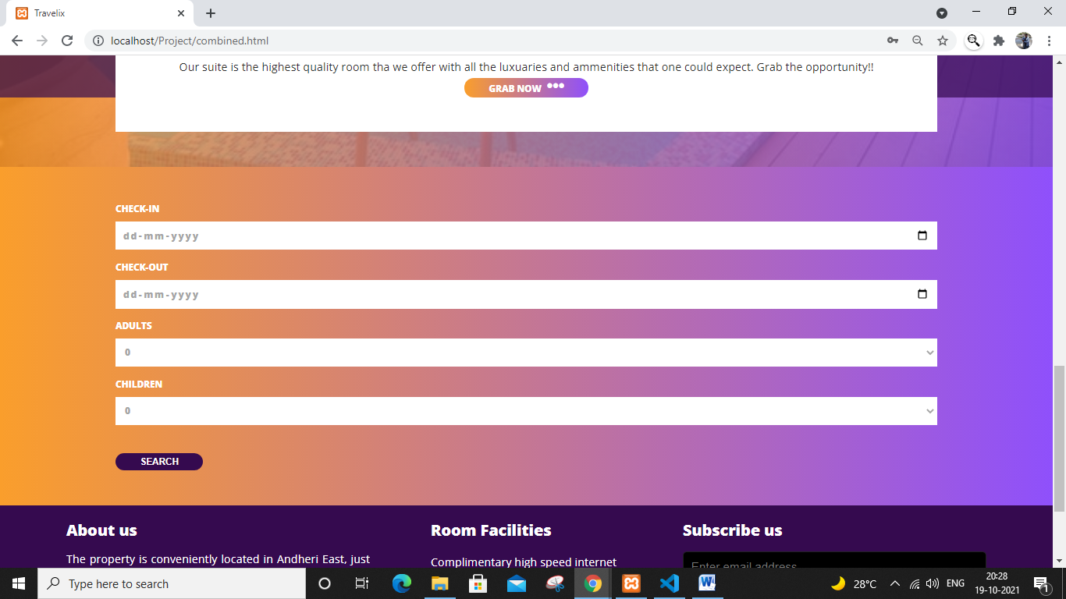

Fig 12: This page also has validation, the check in date must be after the present date and the check out date must be after the check in date.

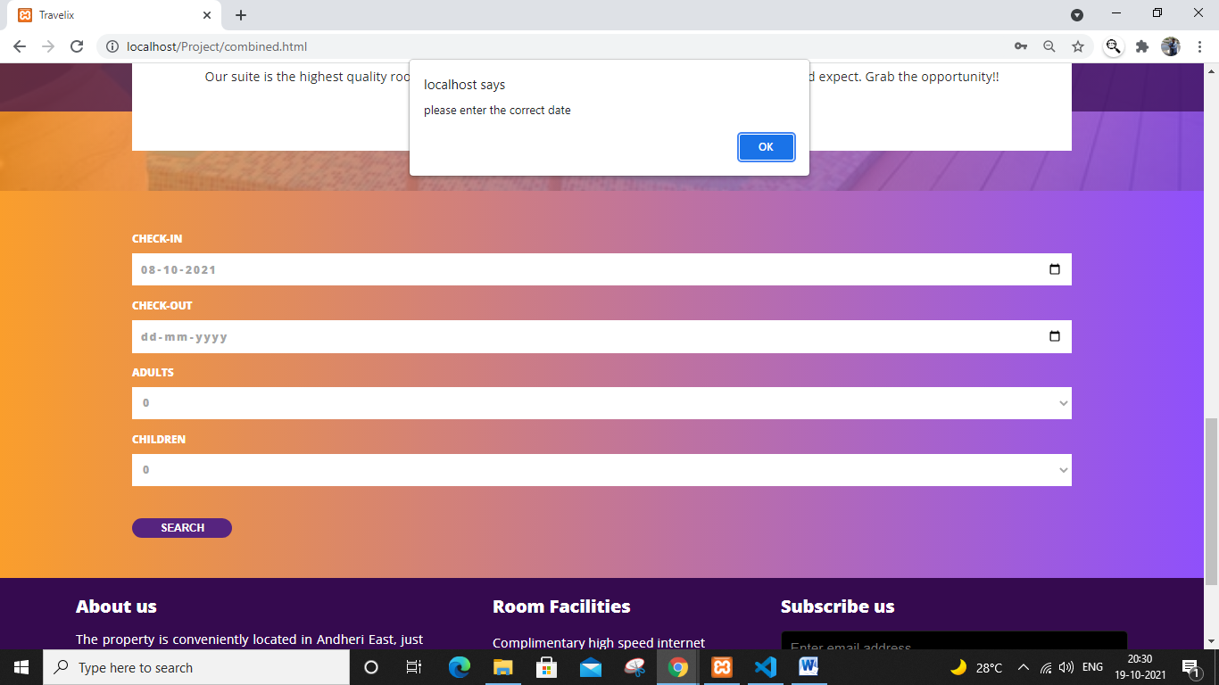

Fig 12: if we enter the date before the present date, then it gives an error

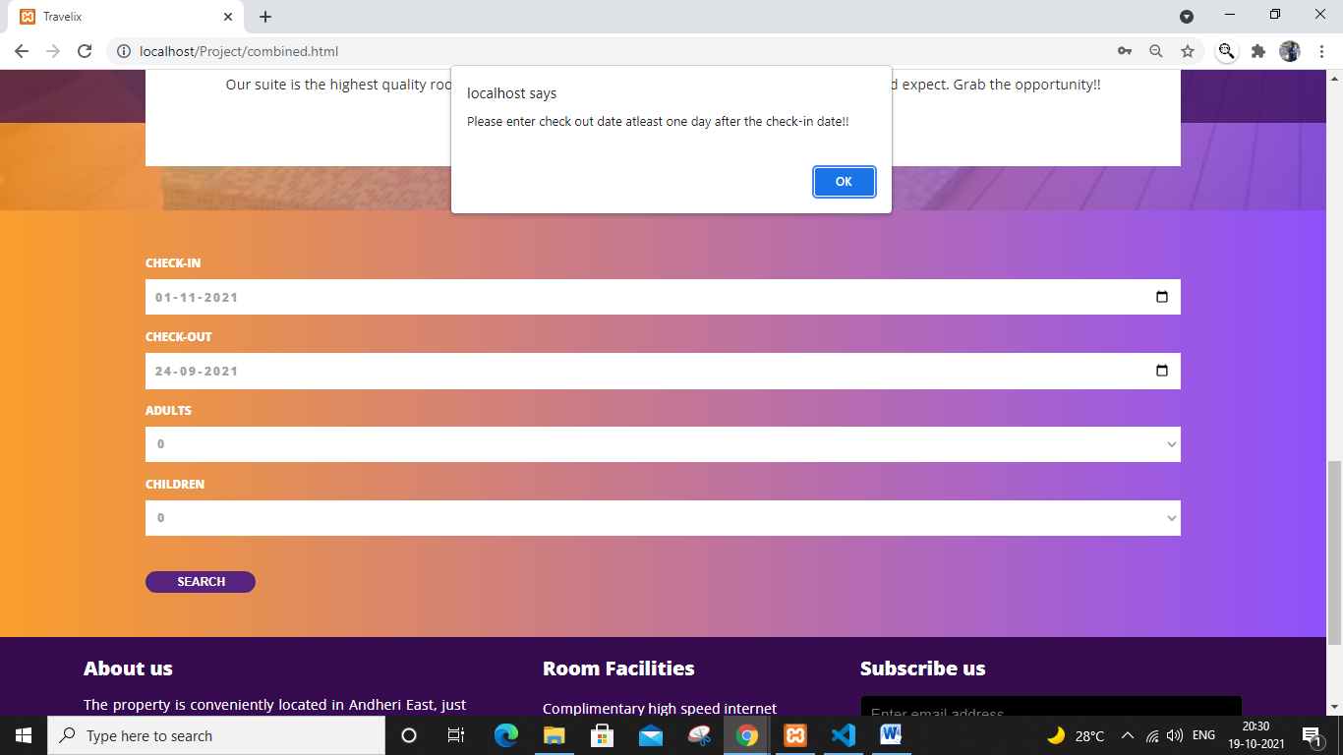

Fig 13: if the check out date is before the check in date, then this is the error

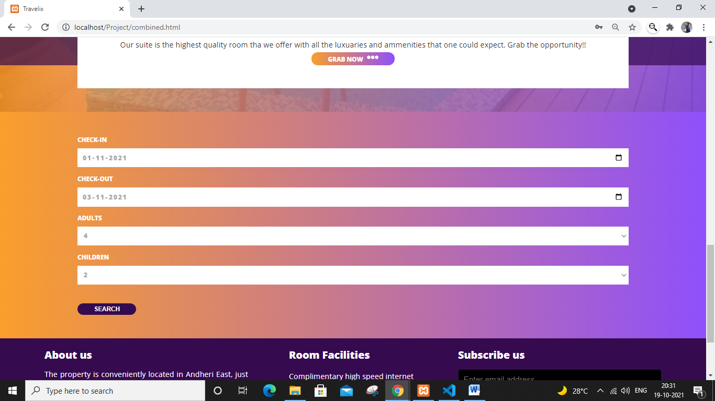

Fig 14: These are the details enter, it will redirect to this page:

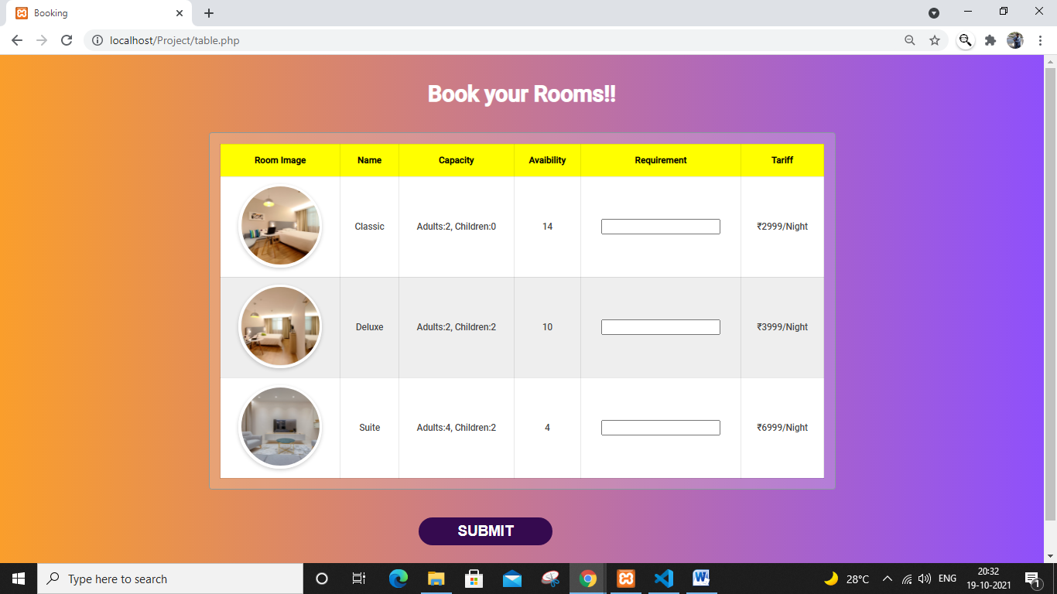

Fig 15: here we need to enter the requirement of the rooms. We have selected that there are 4 adults and 2 children, if the required rooms is less than than the capacity, it will give an error

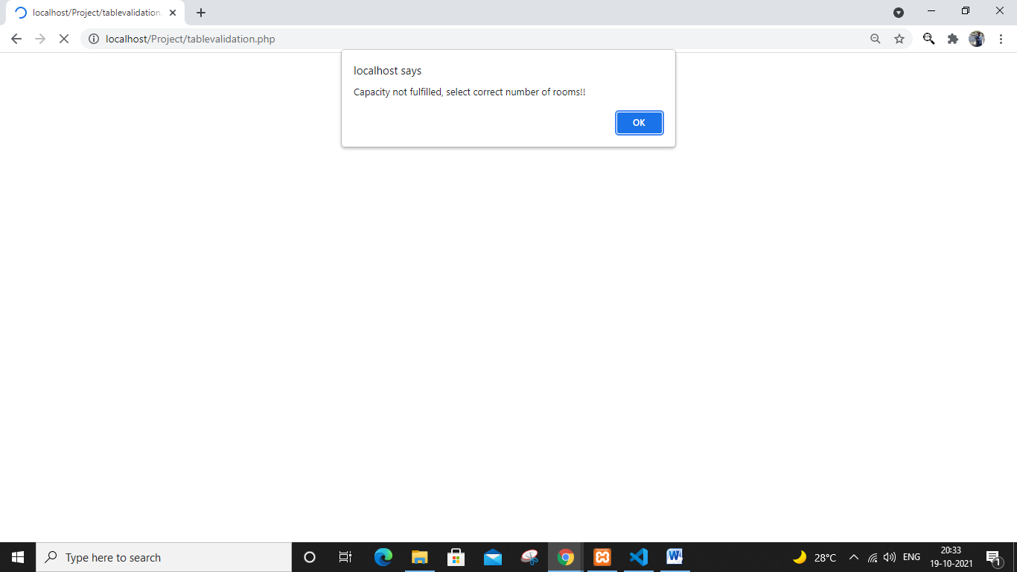

Fig 15:

Now we’ll book a suite room

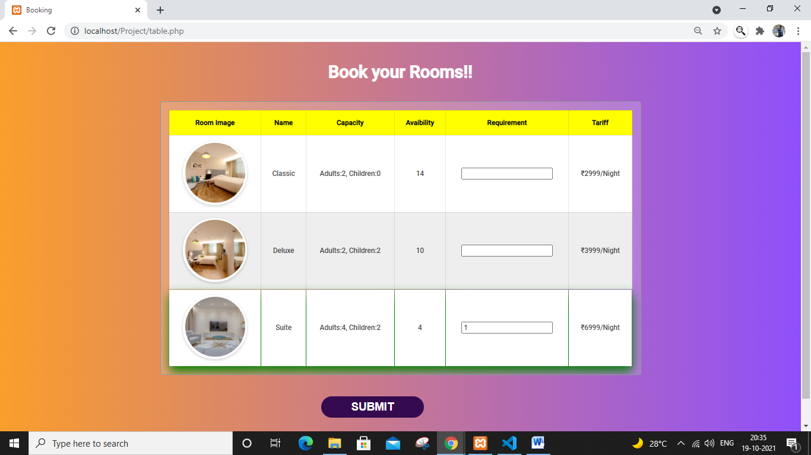

Fig 16: On clicking submit it will take us to the payment page.

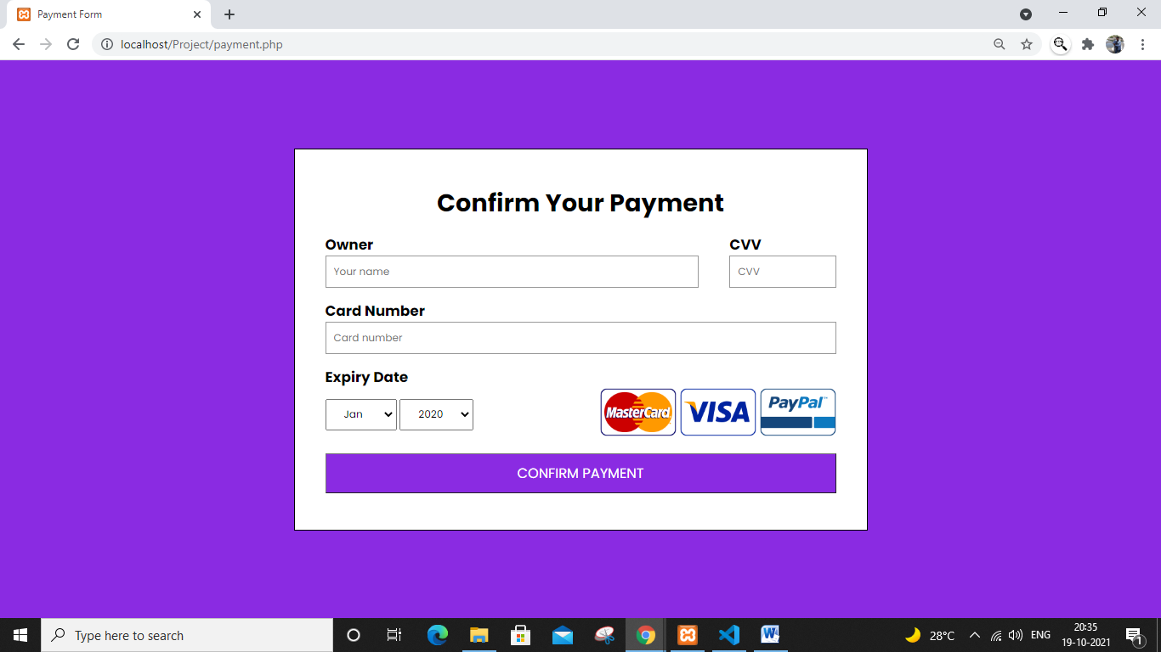

Fig 17: this is the payment page, there Is validation in this page. Like the area cannot be left empty, the cvv and the card number should be of 3 and 16 characters respectively. If not so, then it gives a error

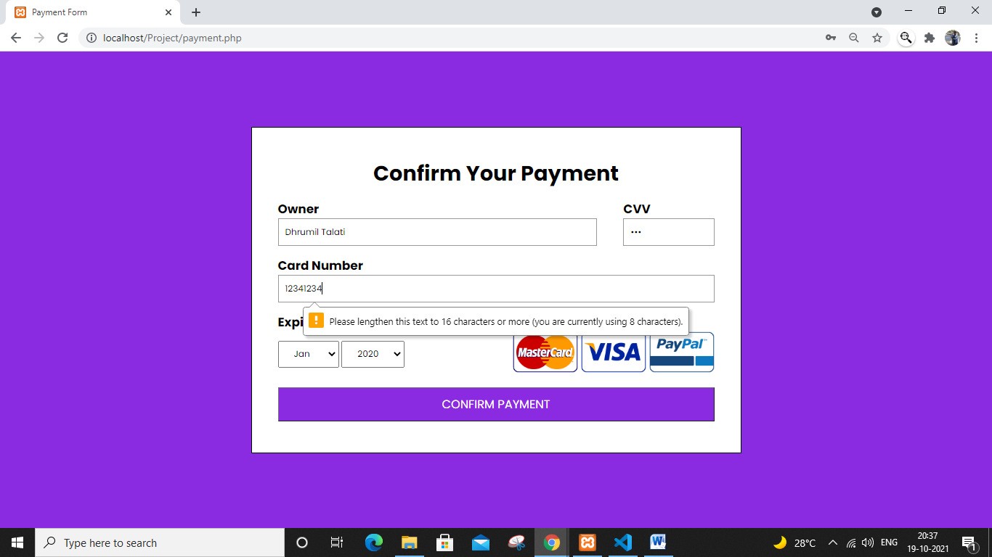

Fig 18

After succesfull entries, then it shows this page:

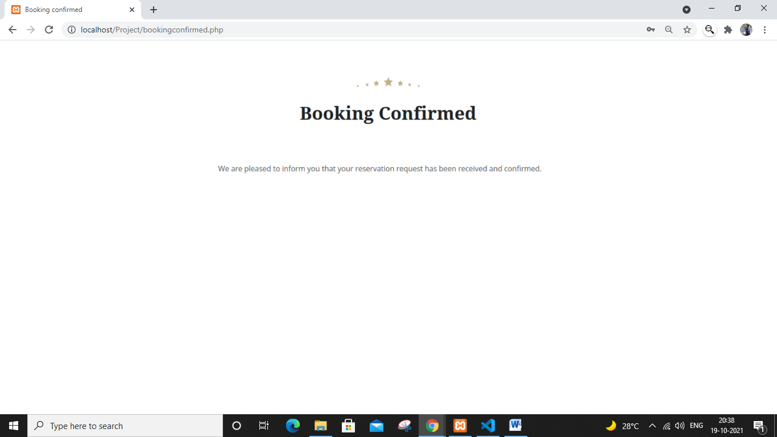

Our website also has a concept of session. If the payment takes more than 3 minutes, then it will a give that session expired

**4.1 Database Created**

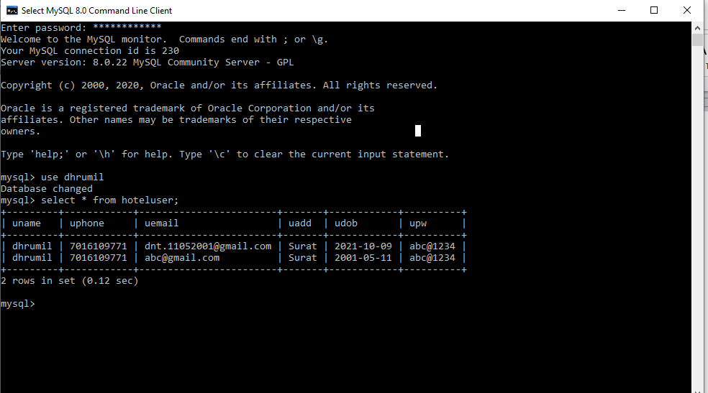

**This is the entry we made in the website**

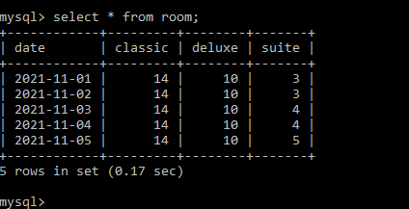

**As we could see in the website, there were 4 rooms in the suite, but now as we can see that, it is now updated as 3 in the table**

1. **DEPLOYMENT OF WEB APPLICATION**

* We wish to deploy the website on the github.

**CONCLUSION**

Through this project, we implemented a hotel website that can book and search for the rooms in the hotel named Travelix. We have implemented this project using HTML,CSS,PHP,JS and MySql. We would like to thank Prof. Dhananjay Joshi sir for this wonderful opportunity. Without his guidance, this website would have been incomplete.

**REFERENCES**